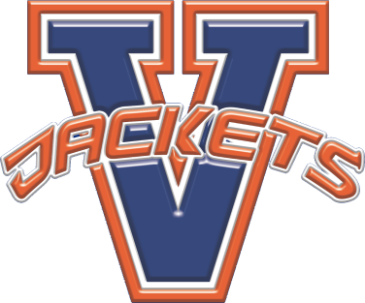
Vision:
Vernon High School will become a school of excellence.
Mission:
The mission of Vernon High School is to INSPIRE all students to value learning, ENCOURAGE all students to develop ethical decision-making skills, EMPOWER all students to live productive and satisfying lives, and EDUCATE all students to the fullest level of their potential.
Beliefs:
- Students learn in different ways and should be provided with a variety of instructional approaches to support their learning.
- Students learn best when they are actively engaged in the learning process.
- A student’s self-esteem is enhanced by positive relationships and mutual respect among and between students and staff.
- Student learning needs should be the primary focus of all decisions impacting the work of the school.
- Students learn best when they have appropriate opportunities for success.
- Each student is a valued individual with unique physical, social, emotional, and intellectual needs.
- All students can learn.
- A safe and physically comfortable environment promotes student learning.
- The commitment to continuous improvement is imperative if the school is going to enable students to become confident, self-directed lifelong learners.
- Students need to apply their knowledge in meaningful, real life contexts.

Motto:
P.R.I.D.E.- Personally Responsible In Developing Excellence

